Appendix 9: New Features in v4.3
Cam Analyzer has had many updates since this user manual was written for the original v2.0 for Windows. These include 3.2A (Appendix 3), 3.2B (Appendix 4), v3.8 (Appendix 5), v4.0 (Appendix 6) and now v4.3. Here is a listing of some of the new features for Version 4.3:
Cam Analyzer v4.3 actually has 5 different versions, which include:
- Cam Analyzer Basic (for analyzing cam data from either manual data entry or computer cam files)
- Cam Analyzer Plus (for more detailed analyzing of cam data from either manual data entry or computer cam files)
- Cam Analyzer Basic for use with the electronic Cam Test Stand (CTS) sensors
- Cam Analyzer Plus for use with the electronic Cam Test Stand sensors
- Cam Analyzer Plus for use with the electronic Cam Test Stand sensors, with advanced “Cam Grinder” features

Note that some of these new features apply only to the Plus Version and/or “Cam Grinder” version of the software. Also note that the “Cam Grinder” version contains all Plus Version features.

New Features for the “Cam Grinder” Version Only:
We’ve added a feature to allow for a Test Piece picture to be included with your test files and printouts. Program now does not print pictures if either the Logo or Test Piece picture file does not exist. Fig 9.1 and 9.2A.
Cam Grinder Version has new options where you can create a Cam Card from separate intake and exhaust files in the special Cam Grinder Timing format. Cam Grinder Timing files were added in v4.0 and do not force the centerlines to line up from different cylinders. They do not account for lifter bore angles or firing order effects. Instead the profiles look much as they would when looking at the end of the cam.
New Graph and Report option for Cam Grinder, allow for Crank Degrees or Cam Degrees. If doing Cam Degrees, the program turns Off the Labels of TDC and BDC and always numbers the degrees in reports as numbers, not as a deg wheel. Fig 9.2.
In Cam Grinder version, added a new Rezero Rotary Sensor Option in the Record screen. Fig 9.3.
In Cam Grinder version, added a new Rezero Lift Sensor Option in the Record screen to allow you to specify a certain lift value to be for the lift sensor at it's current position. Fig 9.3.
Added a new profile type for “Measure with Electronics” of "Measure Anything", for cams which are not typical automotive cams. Fig 9.4.
Added a new Graph Type for the Cam Grinder called Overlap Area. It can be done for either Valve Lift or Tappet Lift. You must also include both Intake and Exhaust Valve or Tappet Lift graphs for this graph to be produced. Fig 9.5.
Program now allows for .csv types of output formats and Blair file formats for Exporting. Fig 9.6.
Crank Degrees can now be shown on the Electronics Recording screen in addition to Cam Degrees. Fig 9.3. Program has several new features for Exporting Manufacturing Files, including:
- Added special feature for exporting a Master Cam file. Fig 9.7.
- Added option to export Manufacturing Type file in IGES or IGS format. Then you can also specify the base circle to
.igs files. Fig 9.9 – Fig 9.11
- Added feature to allow user to zero out runout on measured profile. If you set this to Yes, the program will find what the program believes to be the start of the opening ramp and end of the closing ramp. Then whichever lift is higher will be assigned the lift of the base circle of the master cam to be created. This will eliminate any runout of the measured profile being passed on to the master cam. The 'downside' of doing this is that if there is a significant difference between lifts at these 2 points (bad runout on measured cam), there could be a discontinuity at start or end of one of the ramps. Fig 9.9
Added feature to increase or reduce the lobe durations (stretch or compress duration) by a percentage. Fig 9.12
Cam Grinder version lets you manually generate degrees up to 720 degrees. This can be handy for converting cam files “Measured with Electronics” to “Measured by Hand” so you can do modifications on them.
The program now allows much larger Roller Follower diameters, to simulate grinding stones on cam grinders.
If this is set, duration and events are done in Cam Degrees, the Degree Wheel data on main screen is now labeled "Cam Degrees" if doing Cam Grinder timing.
Added the ability to read .P files. Click on File, then Open from All Saved Tests and click on a .P file to open it.

New Features for the Plus Version Only:
There is now a Preference setting to let you keep the Graph on the main screen always at the same graph scales. This can cause problems if you open files for cams with different lifts and durations than you normally run, or the cams you test produce quite different lifts and durations. However, if your cams are always about the lift and duration, this new Preference makes it easier to spot changes with the graph on the main screen. Fig 9.13
Program now states events on the Cam Card are at valve lift if you are using virtual follower rocker arm "Cam on Rocker".
If you are creating a Cam Card from a file which contains only intake or only exhaust data, but you have already picked a file to be associated with this file for the other lobes data, the program now reminds you of the associated file when you create a cam card. You can also choose to change or cancel the file associated with this file.
A new Overlap option has been added to the Custom Duration Report. Fig 9.14
Two major new Options screen have been added for the Cam Card, including when clicking on the Options button at the lower right: More Options and Modify Labels. Fig 9.15.
The program now displays a graph title on the main screen, stating if the profile is measured with the actual follower, or simulated by Virtual Follower and what type of Virtual Follower. Fig 9.4.
The program now saves the current file as a temporary file before making a Cam Card, so that any changes made during creation of the Cam Card can be restored when program returns to the main screen.
The program now allows a roller follower to be one tenth (0.1) the normal lower limit, which is nearly a "knife edge" for the Virtual Follower simulation. This way the Cam Lift numbers can be very close to those measured by the actual pointer, or even smaller.
The powerful “Filter” feature lets you search for files containing particular measurements, or comments, etc. (See Appendix 8 for more info on this feature.) Now the list of files fitting a particular “Filter” criteria are displayed in Notepad with better spacing to allow for very long file and folder names when you click "Print list of all files fitting these conditions". This list now also includes the Cam Number. Fig 9.16
.

New Features for All Versions:
You can now request what to use for "Lift for Rating Events", either .050" .040" (1 mm) or .053" (for Harley Davidson). Added Rated Lift to History Log, and better arranged spacing of History Log columns for information they must contain. Fig 9.17.
The new Mini USB is a possible logger type. Right now this is just a direct replacement of the current Black Box II. In the future we may add more features.
Now if you import a cam profile, and the profile has 0.5 deg increments and more than 400 rows of data, the program checks to see if the first row has a whole degree increment like 0.0, 1.0, 2.0, etc or half degree 0.5, 1.5, etc. The program will use the rows where there are whole degree increments.
Replaced "Copy" with "Copy (or Merge)" to list of Folder Options possible in 'Save As' screen. Fig 9.18. Program now explains why changes in 'Starting a New Test' screen are not saved if you don't start a new test.
Added features so program can check after writing the config file if it is corrupt and whether a backup should be made. A backup file of the config file is now made and used if the main config file has been corrupted.
Form for Starting a New Test now has larger fields for File, Folder, etc names to better display the names completely. Fig 9.19.
Program now saves tests to My-Tests folder if it's original folder was the Examples folder. Overwriting a file from the Examples folder is not allowed.
If you change the printer within the program to something other than the computer's default printer, the program now restores the default printer and printer orientation when it shuts down.
Program now adjust length of folder and file name in History Log to better fit in available space in the 1st column.
You can now import files from the Performance Trends Quick Cam Checker. You need v1.1 A.015 or later of the Cam Checker, which should be a free download on the PerformanceTrends.com website under Downloads. NOTE: The precision of these files are not as good as those measured with the Cam Analyzer on our Cam Test Stand. Fig 9.20 to Fig 9.22.
Added several new features to the “Save As” screen so you can see other files in folders and select these file names as the name to use or edit to use as a new file name. It also has simplified the method of creating a new folder, and listing these file names by date or name. Fig 9.23
Now the browser should be the default on your computer. Previously it only looked for Internet Explorer. When you resize the main screen, it is more reliable at refreshing all controls and pictures.
Program can now better display PDFs in some versions of Windows 10.
Did lots of refinements to the buttons on the Graph screen which let you enlarge or shrink the graph, or shift the graphs left, right, up and down. Prior to this, the action could get "stuck" or not do the action exactly as expected.
Program has several refinements for reading CPP files more accurately and reliably.
Added new Cam Layout types of "Hemi 99" for race only Mopar, the modern Mopar Hemi 5.7/6.1/6.4L, the GM Gen V LT-4 2015, and fixed a bug in Pontiac cam design layout. Cam Layout types are used for data files types of “Measuring with Electronics”. Fig 9.24.
Program now reports significant figures for lift to 5 decimal places. The measurement resolution of lift sensor is .00004 inches, so going to more than 5 decimal places does not produce any more accurate results.
Program can now read SVL files (from 4stHEAD program).
Program now just displays "Hydraulic" or "Solid" for the Lifter Type for cams that are Measured with Electronics. Previously you could specify various roller or flat Lifter Types, but that did not make sense for cams that are Measured with Electronics.
Replaced linear interpolation with curve fitting for exporting cam files for all versions.
Files and folders you delete now are actually sent to the Recycle Bin so they can be recovered later if you want. Fig 9.25. Program is now better at adding numbers to the end of file names by default.
Now when you open a file which has a Graph Name specified in the History Log, that Graph Name stays with the file. Previously it was restored to the default File Name as being the Graph Name.
Program now tells you your specs "MATCH" the master specs. Before it said "DO MATCH" and many people mistakenly read this as "DO NOT MATCH".
Fixed minor bug where if you changed the Graph Name for the first file in the History Log, it would not stay permanently. Fixed bug where if cam file has only exhaust lobes, you could not open it from the History Log on the main screen.
Refined the program to be better at reading Black Box II when you have selected the Preference of 'Assume Asian Operating System'.
When converting files between Inches and MM lift, now the program uses more decimal places for all files types for more precise conversions.

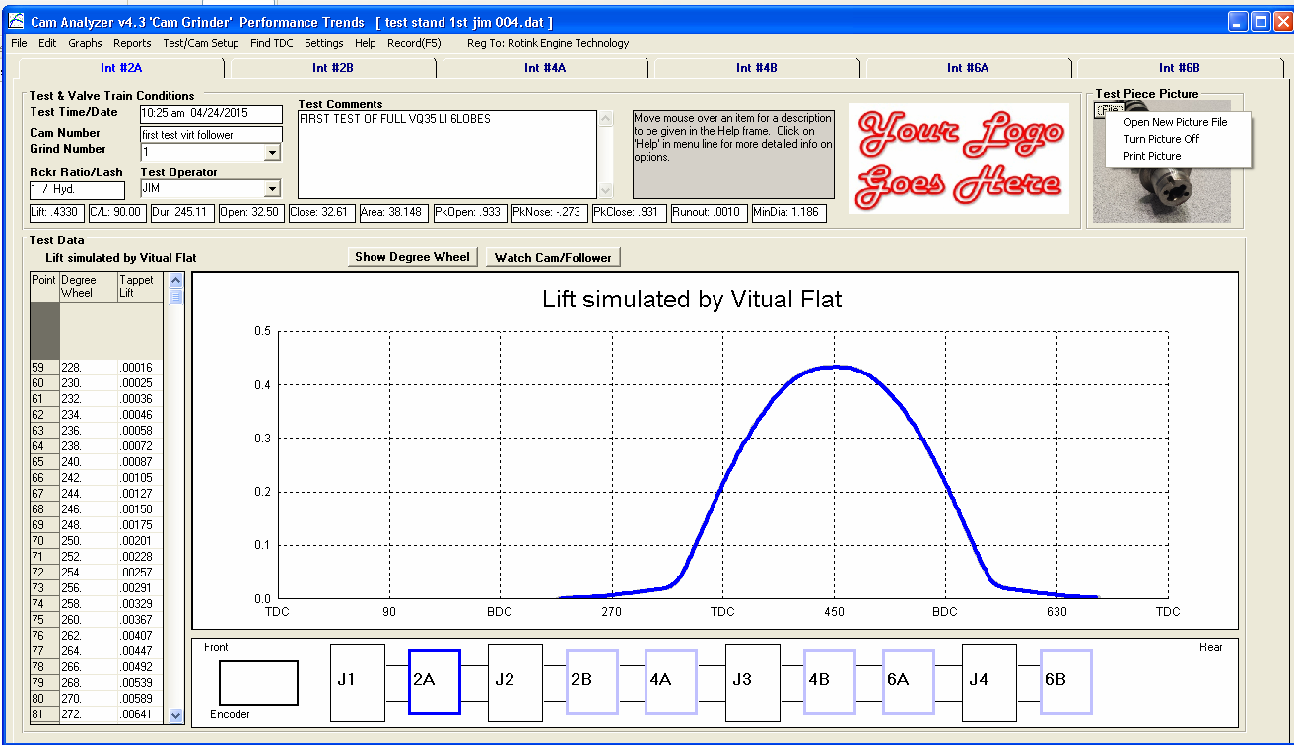
Figure 9.1 New Options on Main Screen
New graph title showing how lift curve is arrived at.
Click on File button for picture options.
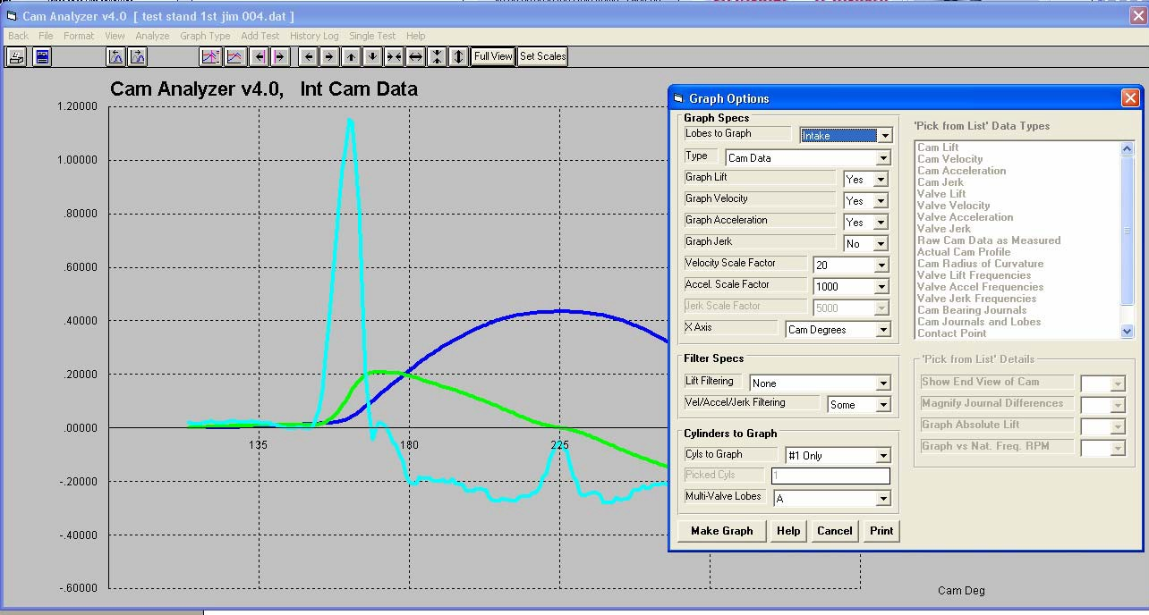
Figure 9.2 Graphing vs Cam or Crank Degrees.
Cam Degrees
180 degrees is TDC
New Cam Degrees Option
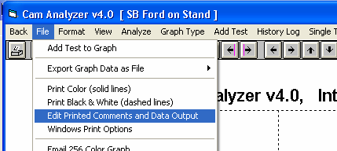
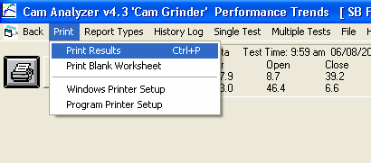
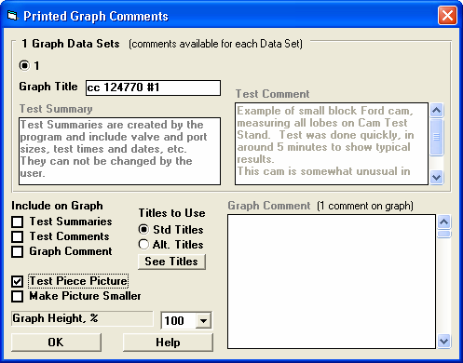
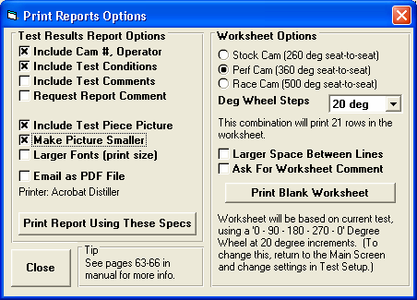
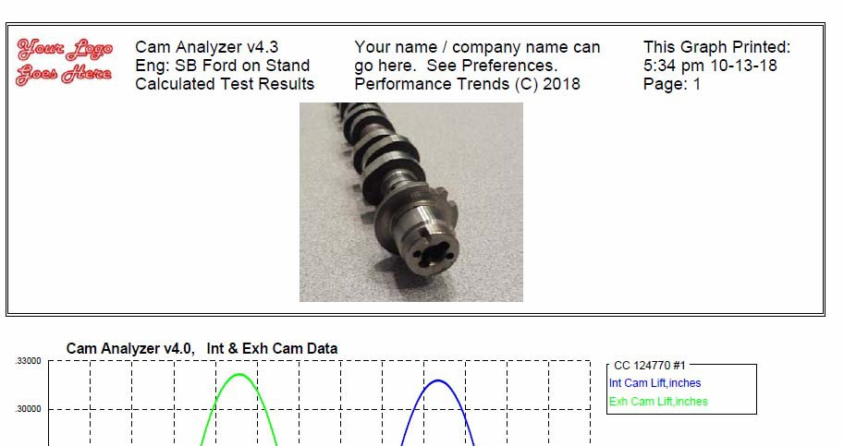
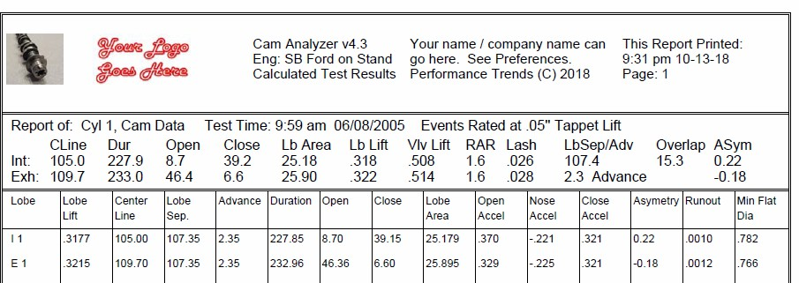

Figure 9.2A Print Options for the Test Piece Picture
Click here in Report Screen for printing Test Piece picture options.
Click here in Graph Screen for printing Test Piece picture options.

Options for printing Reports.

Options for printing Graphs.

Graph printout with Test Piece Picture with Make Picture Smaller not checked. If in Landscape view, this will work differently.

Graph printout with Test Piece Picture with Make Picture Smaller checked. If in Landscape view, this will work differently.
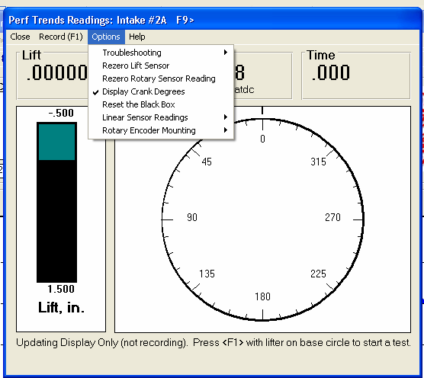
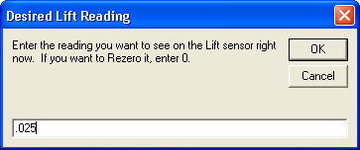
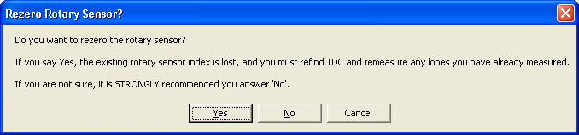
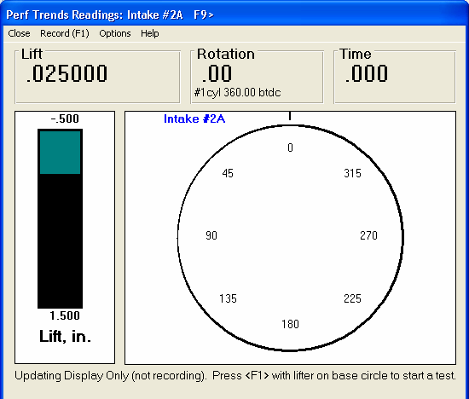

Figure 9.3 Resetting Lift and Degrees in Recording Screen

New Rezero Options

Option checked to display Crank Degrees.

Crank Degrees being Displayed.
Readings now read as you directed by screens above. This feature is typically only useful for manually finding different things on the stand, like, how much lift on the intake ramp is produced by exactly 10 degrees of rotation. A cam profile measured with these changes will be exactly the same without these changes. However the timing will be changed by the amount you changed the rotary encoder.
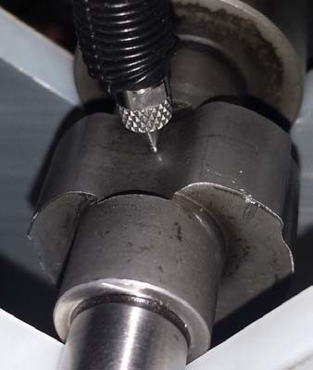
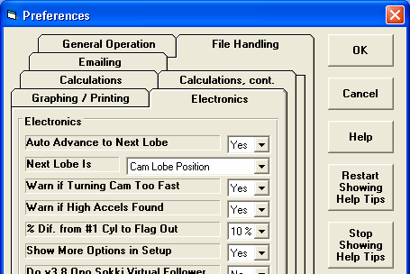
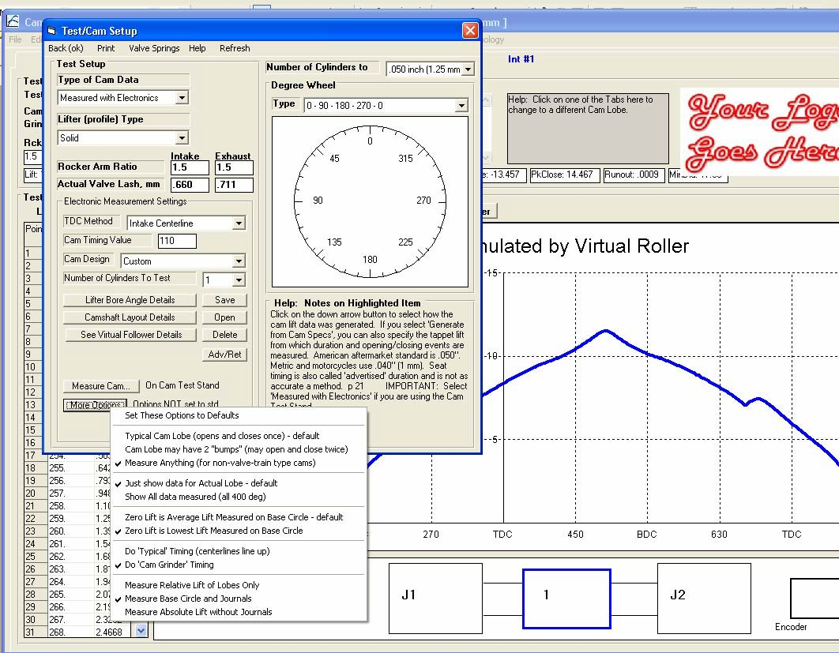

Figure 9.4 Measure Anything Option To Measure Unusual Cams

Cam with unusual profile being measured with special “Precision Tip”
Turn this Preference On for “Measure Anything” option.

Cam Grinder and Plus versions show if lift is simulated by Virtual Follower.
Choose this type of Lobe
Because there may not be a normal “base circle” for unusual cams, it is typically best to also set this option for Zero Lift.

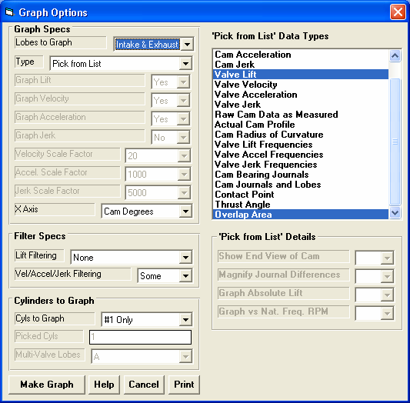
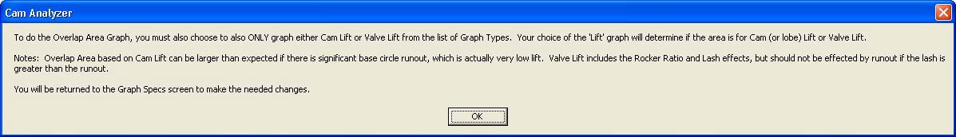
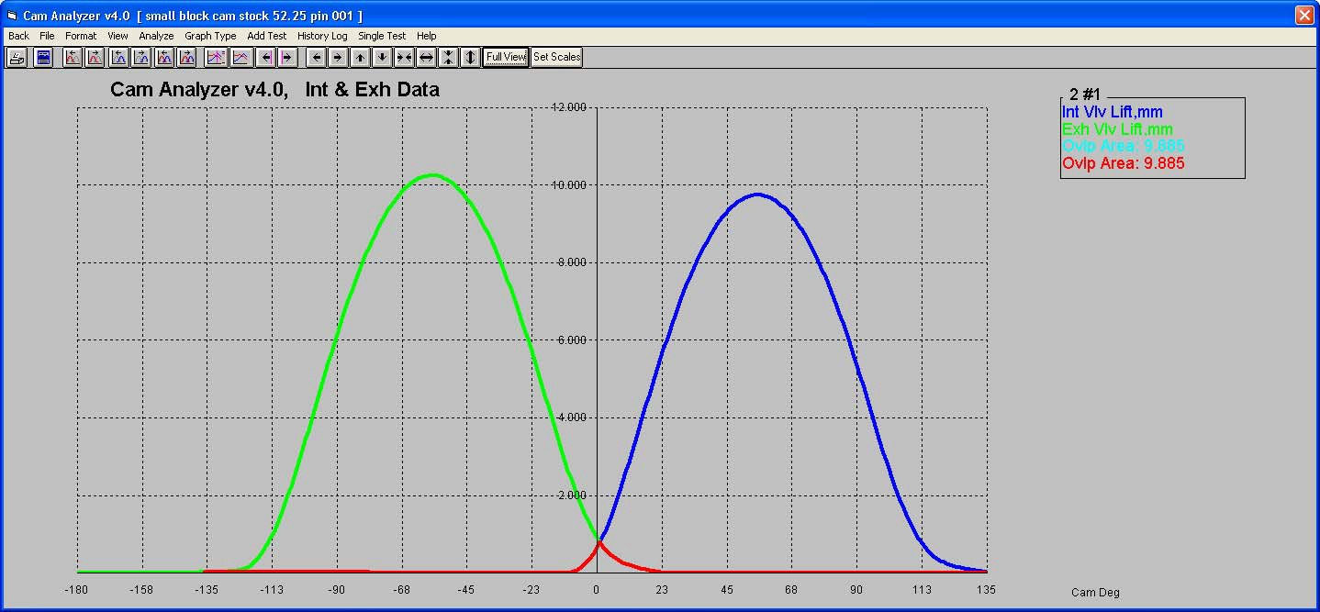
Figure 9.5 Overlap Area Graph
Choose Intake & Exhaust

Choose “Pick from List”
Choose either Cam Lift or Valve Lift
Also choose Lobe Area

Make other choices, like Filtering and Cyls to Graph, then click Make Graph

Overlap Area also shown here as a number of mm degrees (or inch degrees if English Units).

Overlap Area Graph in different color than lift graphs.

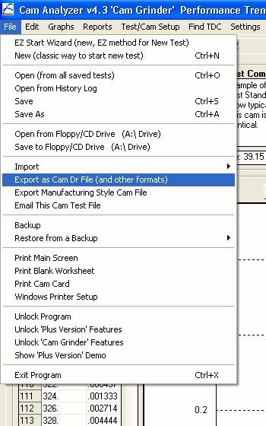
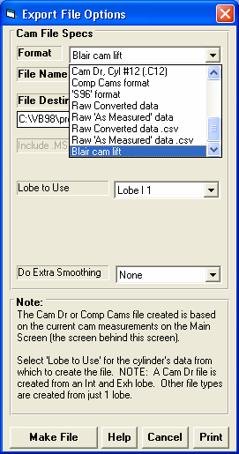
Figure 9.6 Export File Options for Cam Grinder Only

Choose this Export Option
Three new output format types, only available in Cam Grinder version.

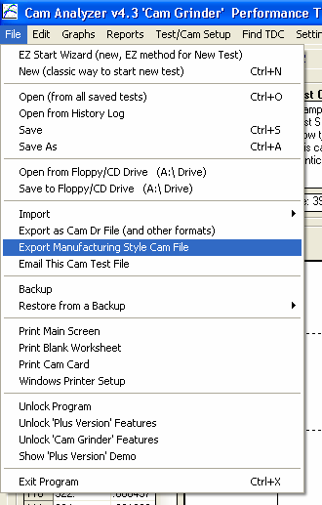
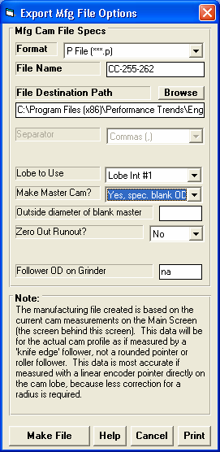
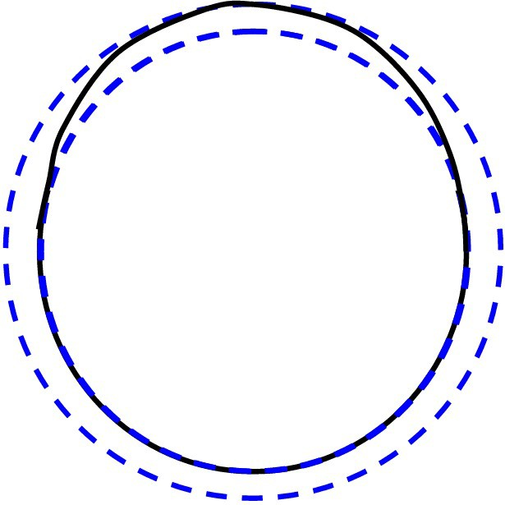

Figure 9.7 Advanced Export Manufacturing File Options

Choose this Export Type

Master cam profile.

“Yes, spec base circle” and you enter the diameter of the base circle when the master is finished.
“Yes, spec blank OD” and you enter the Outside diameter of the blank that the master will be created

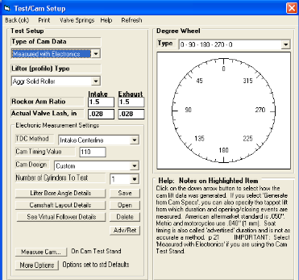
FAQ From Website: How do I create a manufacturing file to exactly copy of a cam lobe I just measured?
Figure 9.8 Open Virtual Follower Details
You need the Cam Grinder version of the Cam Analyzer to do this. First you must measure the cam using the Virtual Follower option, available via the "See Virtual Follower Details" button in the Test/Cam Layout screen, as shown in the screen below.

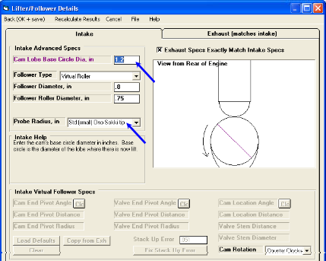
You can use either the .750" diameter Universal Roller or the linear encoder's standard tip directly on the cam lobe. The critical specs to set are the Base Circle you will measure from the cam you are measuring, specifying one of the Virtual Follower "Follower Types" (recommend Virtual Roller), and the Probe Radius you are using.
Figure 9.9 Virtual Follower Details Screen

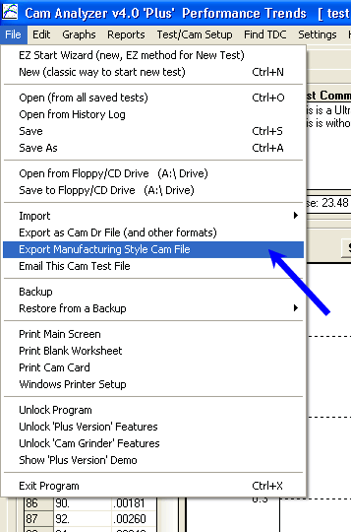
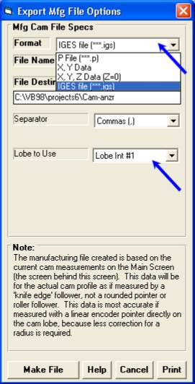
Figure 9.10 Export Manufacturing Style Cam File

Then measure the lobe you want to duplicate with the Cam Test Stand. When you have the lobe measured, click on File at upper left of main screen, the Export Manufacturing Style File from the list.
In the Export screen which comes up, choose IGS as the file type at top (or one of the others if you are sure you can use that type), the file name, file destination and which Lobe to Use (the one you measured). Then click on the Make File button. IGS is the Format recommended because many CAD/CAM programs like SolidWorks and Mastercam will import it directly.
A portion of the resulting IGS file is shown below in Notepad below.

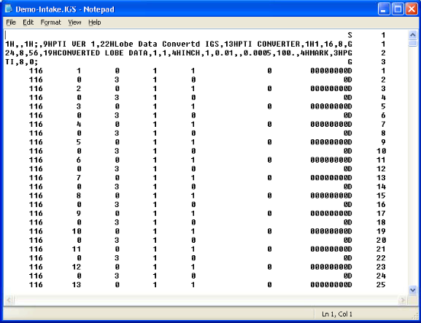
Figure 9.11 Example of Export Manufacturing Style IGES File
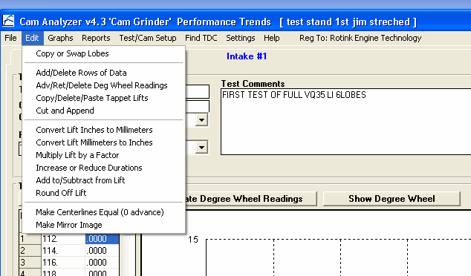
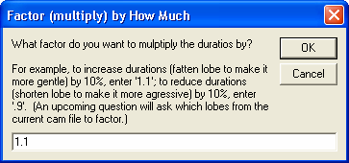
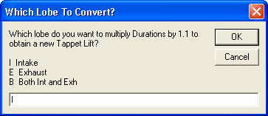
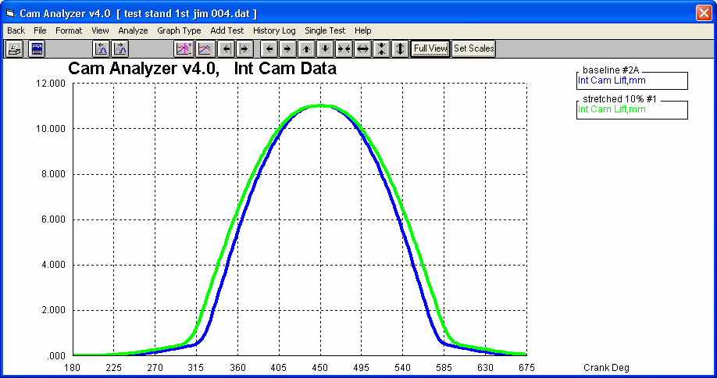

Figure 9.12 Edit Feature to Increase or Reduce Duration of a File

Click Edit, the “Increase or Reduce Durations”

Note: You can only do this to profiles “Measured by Hand”. You may have to convert a different type of profile (like “Measured with Electronics”) to “Measured by Hand” before doing this edit. Check Appendix 5, Figure A29 which describes converting a file to “Measured with Electronics”. Converting to “Measured by Hand” works similar.

Profile with Durations increased 10%
Original Profile

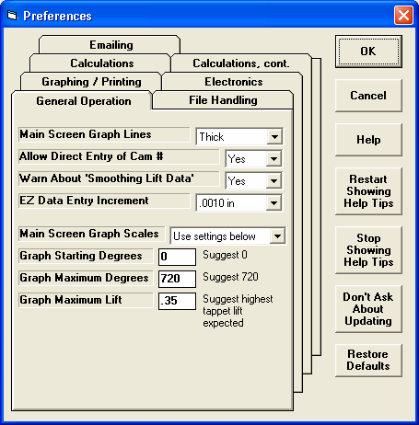
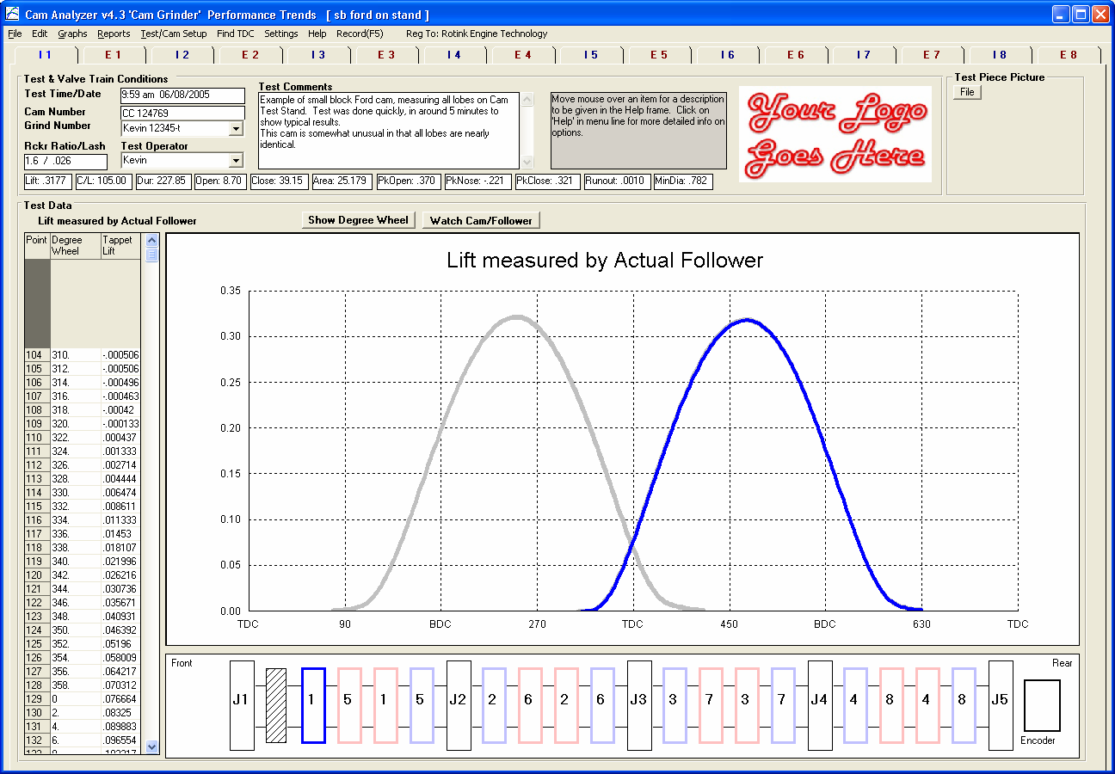
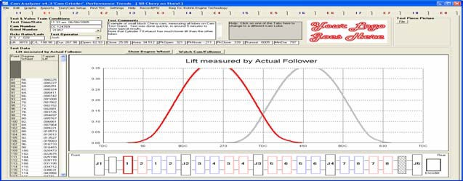

Figure 9.13 Preference to Always Use Same Graph Scale on Main Screen

Turn this Preference to “Use Settings Below” to enable Graph settings.

Graph on main screen using Preference settings

If a cam profile does not fit in these settings, it may be cut off the display or be shown very small.
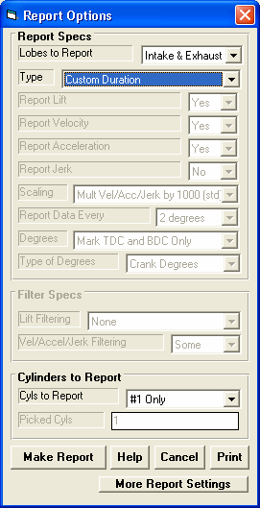
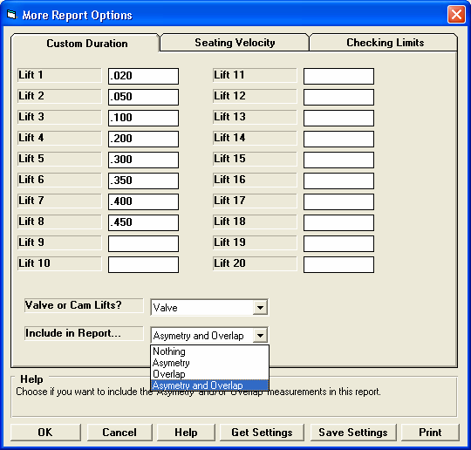
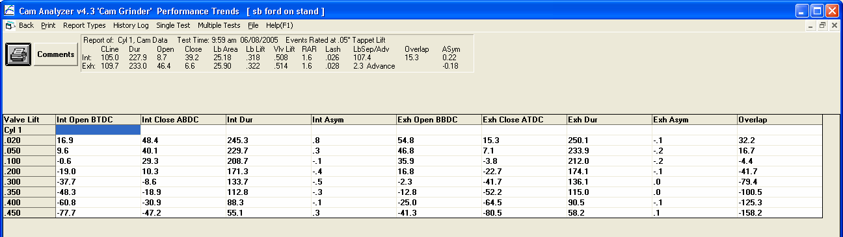

Figure 9.14 New Overlap Output for Custom Duration Reports

Choose Custom Duration report and select “Intake & Exhaust” for “Lobes to Report”
Click here to bring up screen to the right.
Choose one of these settings with “Overlap”.

Overlap shown for the different lifts.

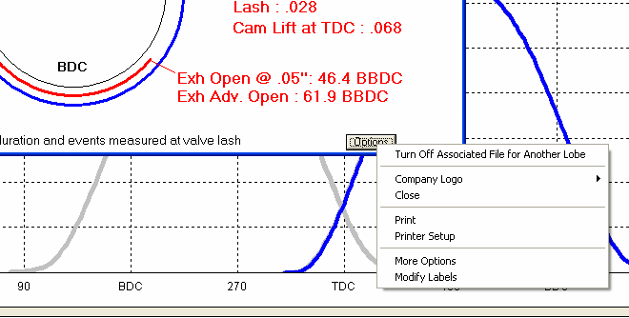
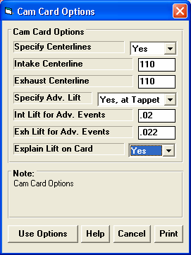
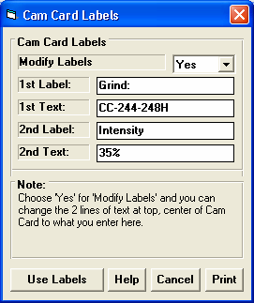
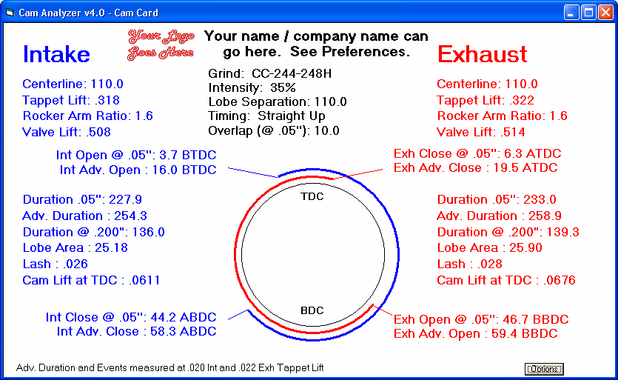
Figure 9.15 New Options for Cam Cards

Click Options button, then one of these 2 new options at the bottom of the menu displayed.

Centerlines are now both 110 deg as set in Cam Card Options.
1st Label and 2nd label are shown here on these first 2 lines, as set in Cam Card Labels.
Advertised Duration and Events now for lifts set in Cam Card Options.
Lash still shown as what you set in Test/Cam Setup, which can be different than lift for Advertised Duration and Events.
Explain Lift on Cam Card

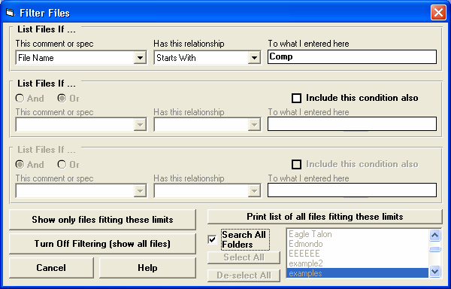
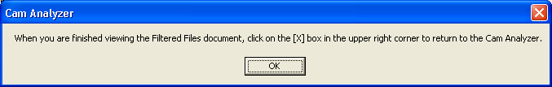
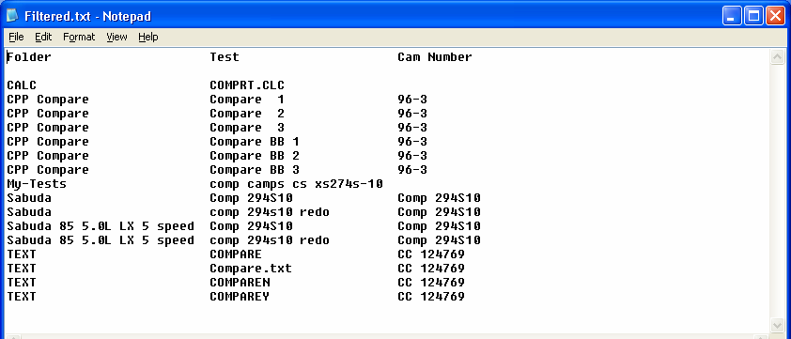

Figure 9.16 New Features for Filtering (Finding) Files
See Appendix 8 for more info on using the Filter feature.

Click here to find all files meeting your search (find or filter) criteria.

Search results are now shown in Notepad so you can print, save, or copy them to the clip board.

The width of these columns adjust to fit whatever width is need to completely show the names.
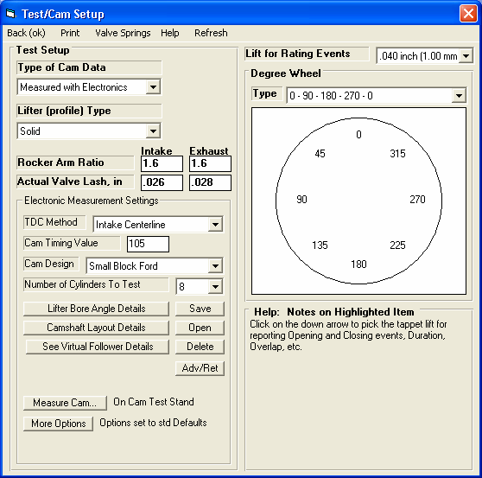
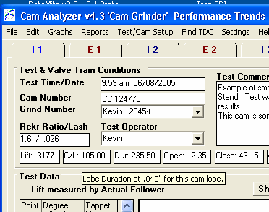
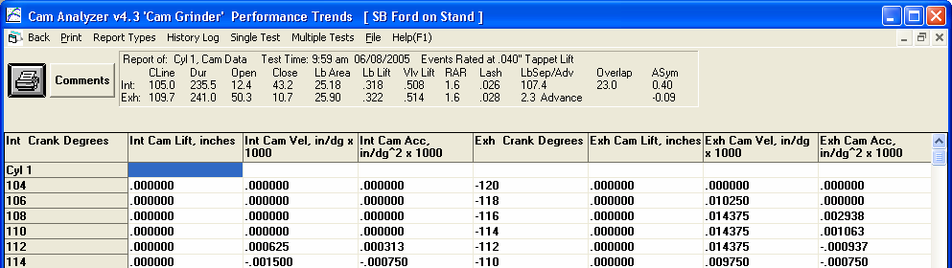
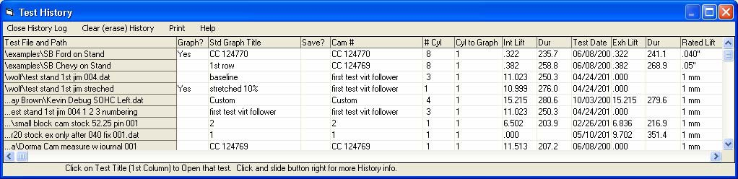

Figure 9.17 Lift for Rating Events
In Test/Cam Setup screen you can now specify what lift should be used for determining events and durations.

Duration and events for that lift shown on main screen.

Lift for Rating Events shown here in Test Summary. Test Summaries can be included in printouts.

Events in History Log are also determined by this “Rated Lift”.

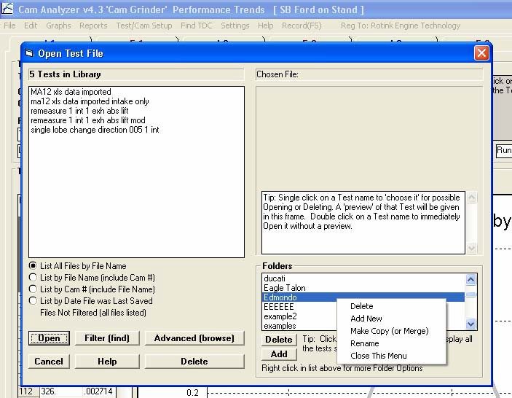
Figure 9.18 New Folder Options in Save As
Right click on a Folder for this menu of Options.
File and Folder fields are now larger to completely display longer names.
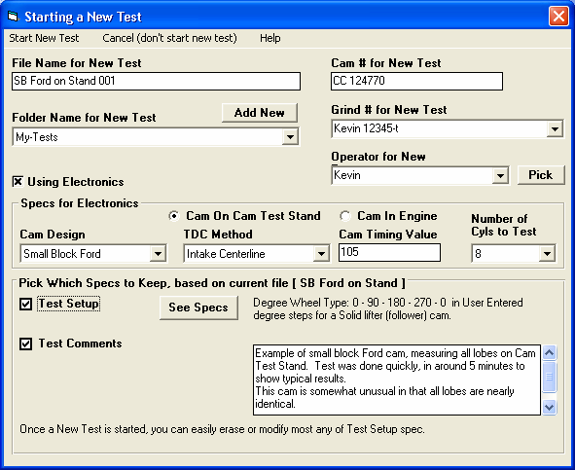
Figure 9.19 Larger Fields for Longer File and Folder Names when Starting a New Test
Several fields are now larger on the “Starting a New Test” screen.
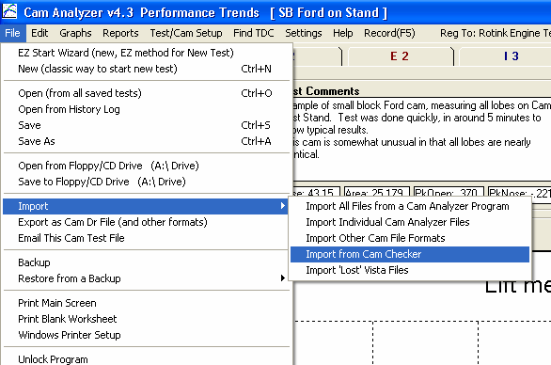
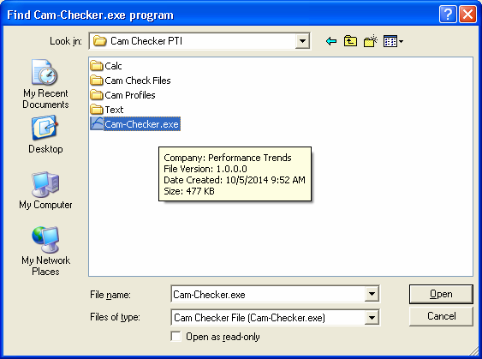
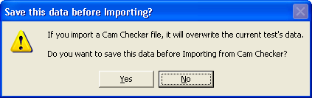
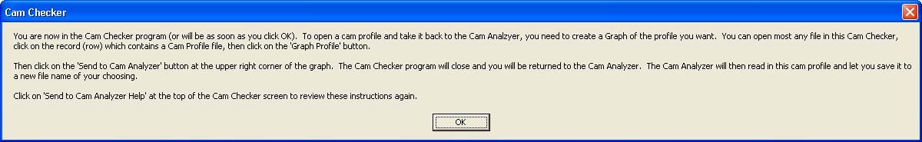
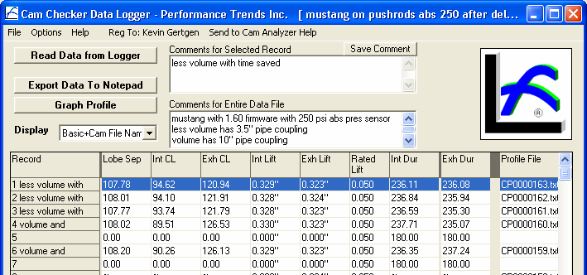

Figure 9.20 Importing from Cam Checker
Locate the Cam-Checker.exe program, and click Open button at lower right. Once it is located, the program will remember it.

Choose this Import option.

If this current file does not have the profile you want to Import, click on File and open a different file.
Click here to review this Help Screen again.

Click on a record (row) which has a Profile File to highlight it.

Once you have selected a record, click the Graph Profile button.
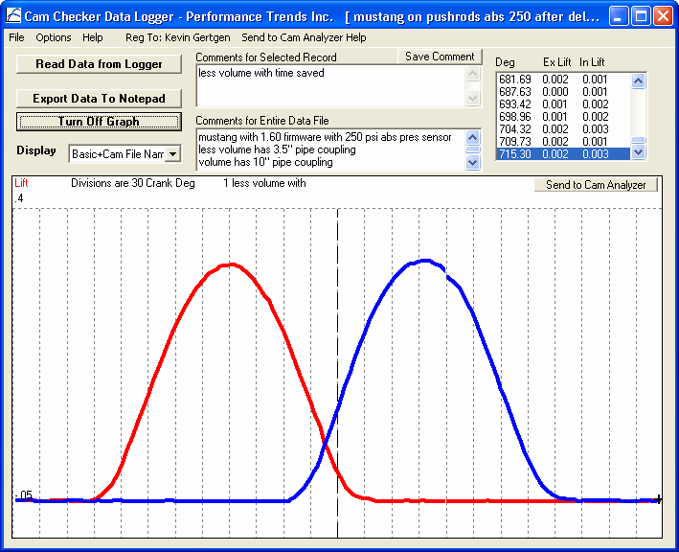
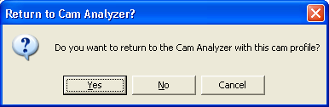
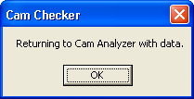
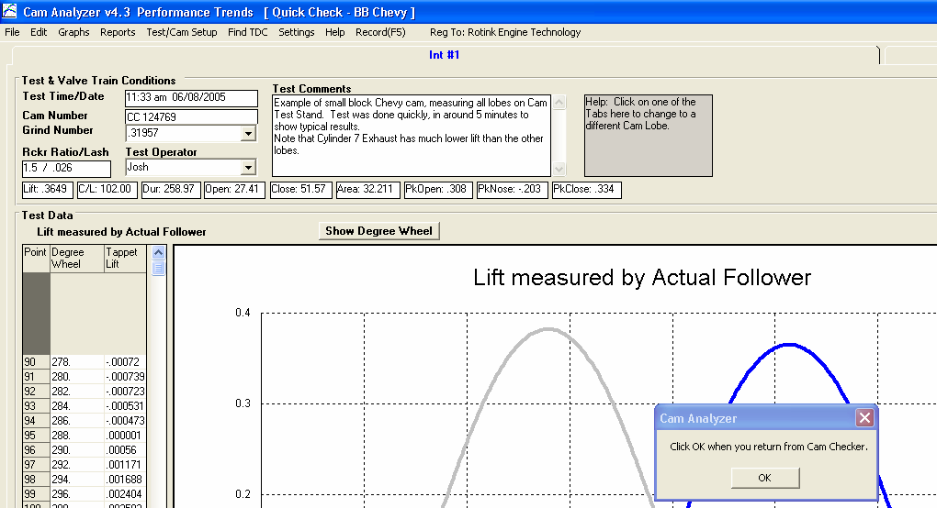

Figure 9.21 Importing from Cam Checker, cont

Once the profile is graphed, click this button.

The Cam Checker software will close and you can click this button once you are back at the Cam Analyzer.
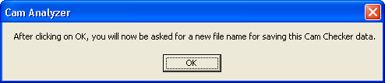
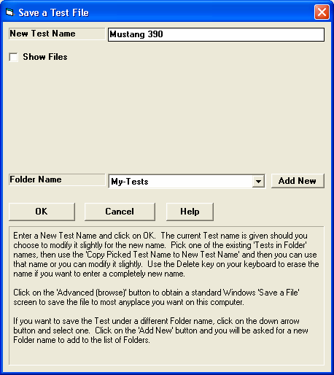
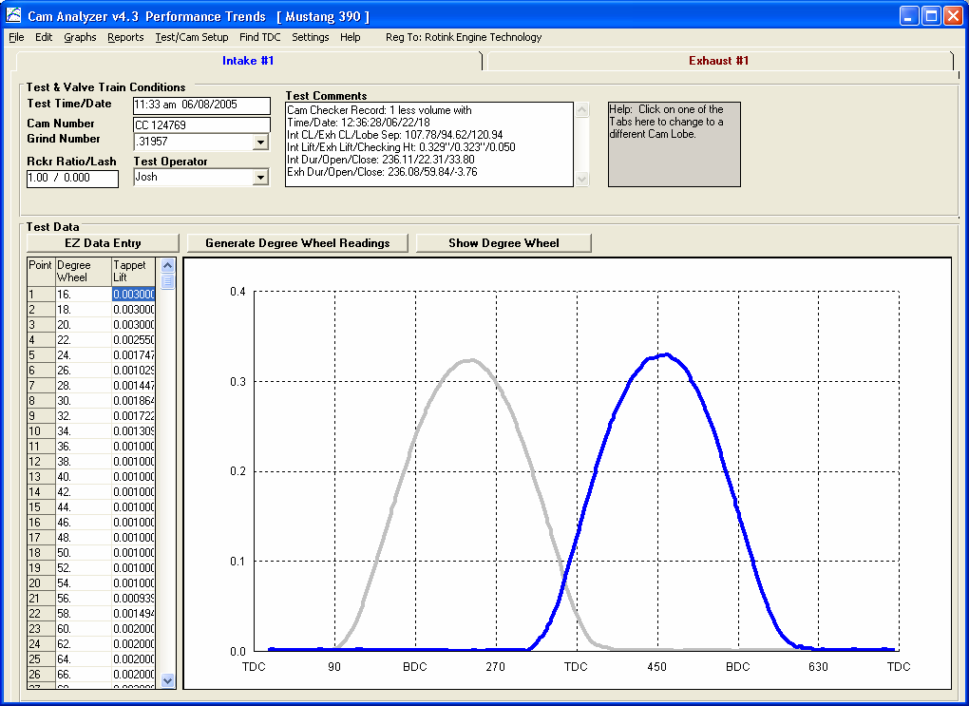

Figure 9.22 Importing from Cam Checker, cont

After clicking on OK on the Cam Analyzer messages, enter a name for saving the data Imported from the Cam Checker.
You can also choose a folder or choose to add a New Folder.

Cam Analyzer with new Imported Cam Checker data and file name.
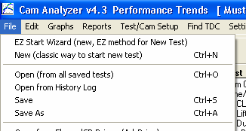
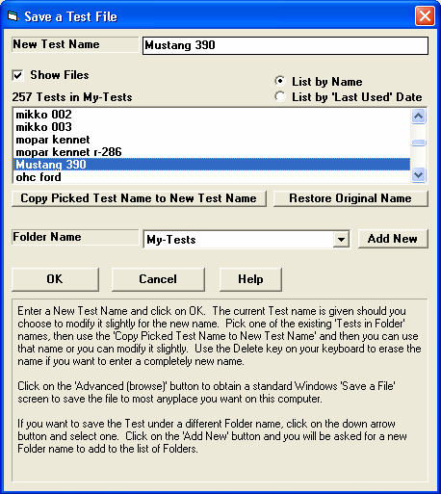
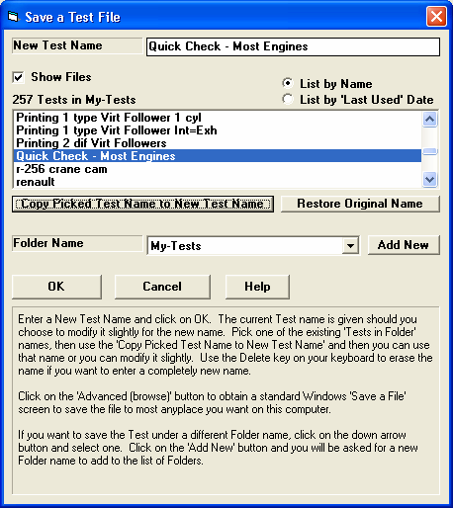
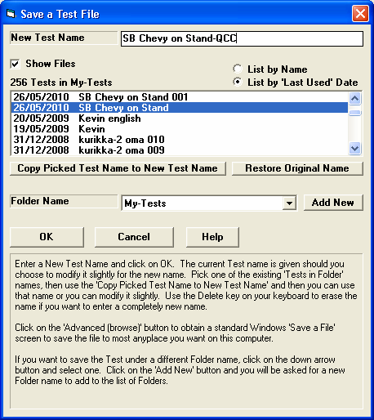

Figure 9.23 New “Save As” Features
Click on File, then Save As

Click this Check Box for new info and options. Many times you may want to see what other files are in this same folder, or use one of these file names as the New Test Name, or possibly modify that name slightly.

Here we are listing Test Files alphabetically by name.

Choose a Test name from the list, then click here to copy that name to the New Test Name field.
Using the Picked name and then modifying it slightly.
Listing by Date

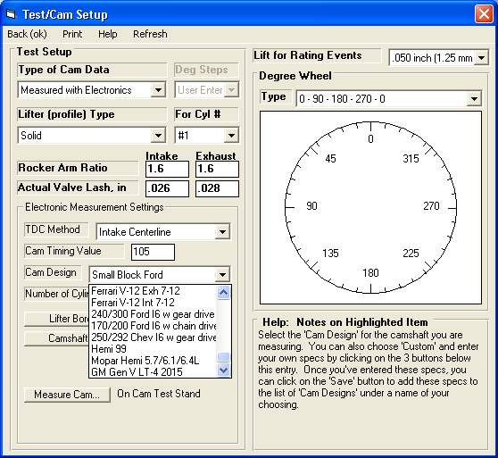
Figure 9.24 New Cam Layouts
Three new Cam Layouts. Other layouts can have some minor bugs fixed.
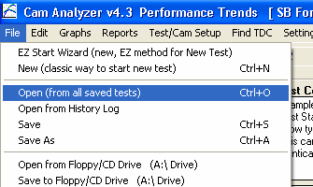
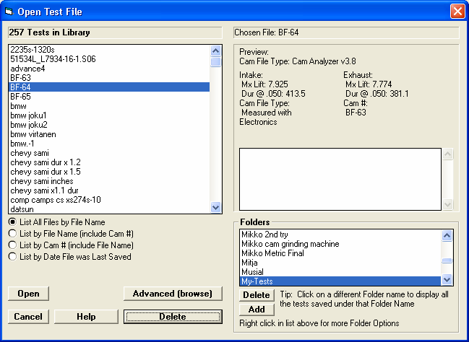
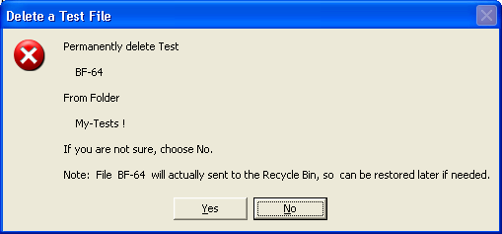
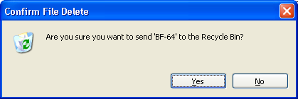
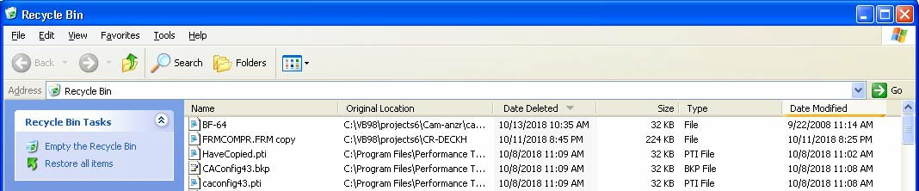

Figure 9.25 Saving Deleted Files and Folders to Recycle Bin

Click here for the Open screen shown to the right.
Pick a Test File, then click Delete button.
Deleted Folders are also sent to the Recycle Bin.

Deleted test file now shows up in the Recycle Bin, so you can restore it later if you have made a mistake deleting it.

